Project Development Phase – Sprint1

|  |  |
| --- | --- |
| Date | 24 October 2022 |
| Team ID | PNT2022TMID22202 |
| Project Name | A new hint to transportation – Analysis of the NYC bike share system. |
| Maximum Marks | 20 Marks |

Data Preparation:

Dataset link : https://s3.amazonaws.com/tripdata/index.html Uploading the dataset

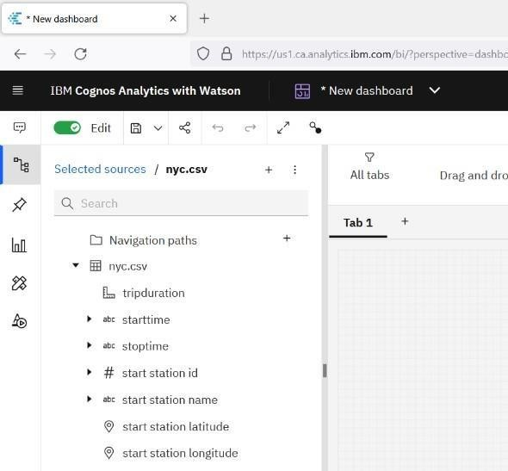

Data Cleaning:

Finding the duplicates:

df = data[data.birthyear.notnull()] df.duplicated().sum()

0 # There are no null values present in birthyear

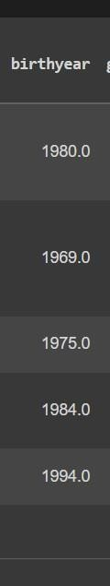

**Checking null values:** d=df.isna().sum() d.head()

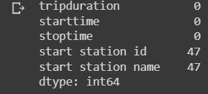

**Replace null values:** df.replace(np.nan,'-',inplace = True) df.isnull().sum()

